**NOTE**: You need a public StartUp class with the namespace Stealer.

You are already an expert on **High-Quality Code**, so you know what kind of **access modifiers** must be set to the members of a class. You should have noticed that our hacker is not familiar with these concepts.

Create a method inside your Spy class called - AnalyzeAccessModifiers(string className). Check all of the **fields and methods access modifiers**. Print on the console all of the **mistakes** in the format:

* Fields
  + **{fieldName} must be private!**
* Getters
  + **{methodName} have to be public!**
* Setters
  + **{methodName} have to be private!**

Use **StringBuilder** to concatenate the answer**. Don’t change anything in Hacker class!**

In your **Main()** method you should be able to check your program with the current piece of code.

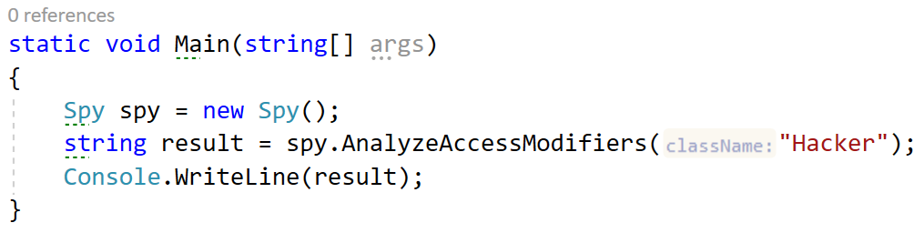

### Example

**NOTE**: **The order of your output** may **differ** based on your **solution logic**.

|  |
| --- |
| **Output** |
| username must be private!  get_Id have to be public!  set_Password have to be private! |